lOMoARcPSD|14619844



[Evidencia GA2 240202501 AA1 EV03](https://www.studocu.com/co/document/servicio-nacional-de-aprendizaje/ingles/evidencia-ga2-240202501-aa1-ev03/29382864?utm_campaign=shared-document&utm_source=studocu-document&utm_medium=social_sharing&utm_content=evidencia-ga2-240202501-aa1-ev03)

[ingles (Servicio Nacional de Aprendizaje)](https://www.studocu.com/co/course/servicio-nacional-de-aprendizaje/ingles/4953035?utm_campaign=shared-document&utm_source=studocu-document&utm_medium=social_sharing&utm_content=evidencia-ga2-240202501-aa1-ev03)

StuDocu is not sponsored or endorsed by any college or university

Downloaded by KR12TH (xkrizthx@gmail.com)





**ENGLISH**

**PRESENTED BY: JAIRO DIAZ SHEET: 2455251**

**YEAR: 2022**

Downloaded by KR12TH (xkrizthx@gmail.com)



**Evidencia GA2 240202501 AA1 EV03**

Downloaded by KR12TH (xkrizthx@gmail.com)



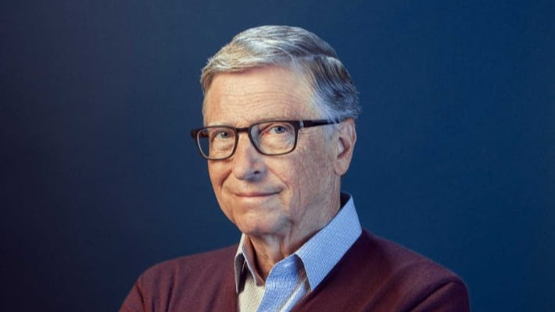

**Bill Gates**

**Seattle, Washington; October 28, 1955**

On April 4, 1975, while still a student at Harvard University, he created the Microsoft software company.



In 1985, Gates was named one of the "50 Most Desirable Bachelors" by Good Housekeeping. He married Melinda French on January 1, 1994 and they had three children.

In a March 2014 Rolling Stone magazine interview, Gates said that, in terms of his faith, ((the moral systems of religion, I think, are super important.

We've raised our kids in a religious way)). In the same interview, Gates said: ((I think it makes sense to believe in God, but exactly what different decision in your life you make because of that, I don't know)).

In 1994, he bought a Leonardo da Vinci manuscript (the Hammer Codex, also called the Leicester Codex) for $30 million.

In 2007 Bill Gates ranked second in the annual list of the greatest personal fortunes compiled by Forbes magazine, behind the Mexican businessman Carlos Slim.

Since 2008, the year he stopped running Microsoft, he has succeeded in some projects in order to spread this lifestyle. In this sense, together with Peter Thiel (co- founder of the PayPal company), he has supported the creation of artificial eggs based on plants that are easy to grow.

In September 2019, Netflix launched a documentary series titled "Bill Gates Under the Magnifying Glass", directed by Davis Gunggenheim, which seeks to understand how the brain of the creator of Microsoft works.

On May 3, 2021, he announced the end of his marriage to Melinda French, after 27 years of marriage, through a message posted on his personal Twitter account. Although they end their personal relationship, they will continue to work together at the Bill and Melinda Gates Foundation.

Downloaded by KR12TH (xkrizthx@gmail.com)